# Homework 21: You sure can attract a crowd!

## Deploying the Crowdsale

1. Set the network as Kovan

![address](Screenshots/01.Kovan.png)

1. Deploy CrowdSale Contract

After compiling the files, we deploy the Pupper Coin CrowdSale Deployer

* We determine the name and symbol of the coin, the wallet behind it as well as the initial supply and the goal, which is set to be the same as the cap.

![address](Screenshots/02.DeployingCrowdSale.png)

After hitting confirm in MetaMax, we have successfully deployed the contract with the various contracts that, after being deployed, will allow us to create the coin and make coin sales.

1. Deploy Pupper Coin Contract

From the contract deployed in the prior step we will use the token address generated to input in this step.

![address](Screenshots/03.DeployingPupperCoin.png)

1. Deploy Pupper Coin Sale Contract

From the first contract deployed, we will use the token sale address generated to input in this step.

![address](Screenshots/04.DeployingPupperCoinSale.png)

Before we move to the next step, we confirm that all the contracts have been deployed:

![address](Screenshots/05.AllContractsDeployed.png)

Buy ARGIE

We will buy from a different account to the account that created the coin, 0.05 ETH + 1 WEI to hit the goal and an extra.

![address](Screenshots/06.PurchaseofCoins.png)

And now, we wait until the crowd sale finishes.

![address](Screenshots/07.WaitTime.png)

We can now finalize the auction and claim our token.

![address](Screenshots/08.Finalize.png)

Add Token to the Wallet and wait until we see the balance!

![address](Screenshots/09.AddToken.png)

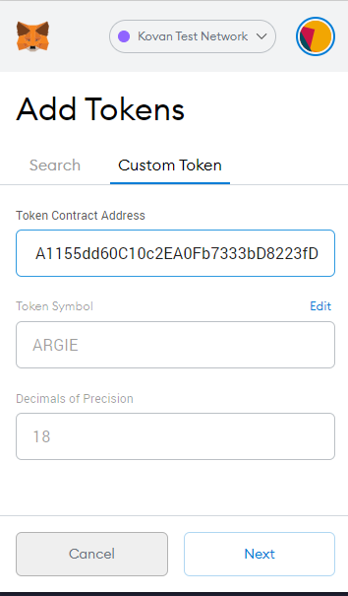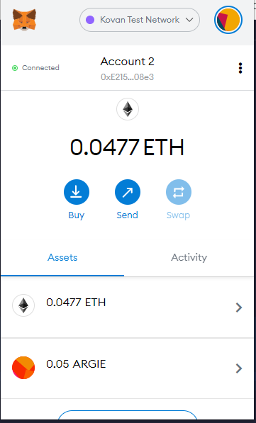

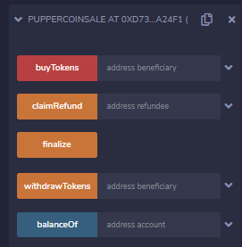

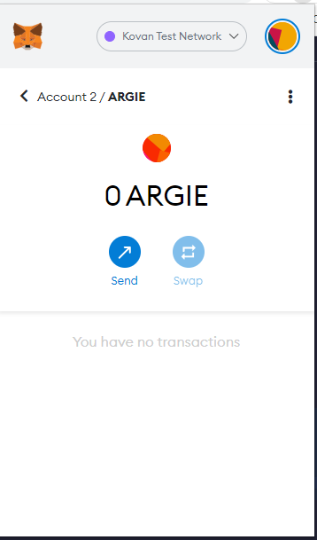

The contract created in level one i ssuch that it enables the pro-rata payment of certain amount accross three employees

The use of the constructor function enables to define any group of three employees at the time of making the deposit

This contract, although a simple one, allows to deposit on a regular basis and in a seamless fashion, for example the wages of a certain group of employees.

### Key Steps:

#### 1. Add Employees's Wallet Addresses

![address](Screenshots/ 01.Kovan.png)

#### 2. Deploy Contract

**Before:**

![deploy](Screenshots/1.deploy.png)

**After:**

![deployed](Screenshots/2.deployed.png)

#### 3. Make Deposit and Choose Transfer Amount in Metamask

**2 ETH to be transferred to three employees**

![transfer](Screenshots/3.transfer.png)

#### 4. Confirm Transaction was Made

![confirmation](Screenshots/4.confirmation.png)